Introduction
Unlike ground-based or airborne approaches, space-based measurements provide broad regional or global coverage with great temporal precision, making them valuable in a number of applications [1]. As climate change becomes more severe, advanced as well as responsive technologies are required. Emerging CubeSat-based hyperspectral optical imaging payloads are meeting this demand, revolutionizing how we perceive climate and environmental change from orbit. These platforms are low-cost, compact, and versatile, making them suitable for remote sensing applications such as weather forecasting, water resource management, pollution tracking, agricultural monitoring, and disaster response, including wildfires, floods, and hurricanes [2].
In 1999, Professor Jordi Puig-Suari of Cal Poly and Bob Twiggs of the University of Stanford [1] devised a pioneering CubeSat design that offered low-cost access to space as a piggyback secondary payload on a large vehicle [3] [4]. Further, they have developed a standard that states that a 1-unit (1U) CubeSat shall measure 10 × 10 × 10 𝑐𝑚3 and weigh no more than 1.33kg, with typical power consumption on the order of a few watts, while available data rates do not exceed 1 Mbps [1]. This platform has also been designed with a wide range of sensor payload systems such as GNSS receivers, spectrometers, and advanced imaging (e.g., a CCD camera) capabilities, allowing them to capture high resolution images of the Earth’s surface as well as investigate other celestial bodies [4]
Figure 1 depicts concept of operation (ConOps) of a 3UCubeSat equipped Hyperspectral optical imager payload along with other subsystem conceptual mission operations to acquire images of the Earth. The prospects of CubeSat platform provide new avenues for commercial applications, including earth observation, communication, and scientific research. These applications have been reinforced by improvements in several technological domains, including advanced electronics and optics, new materials and optomechanical manufacturing techniques, signal processing, computer technology, communication, navigation, and pattern recognition and image processing algorithms [4] [5].
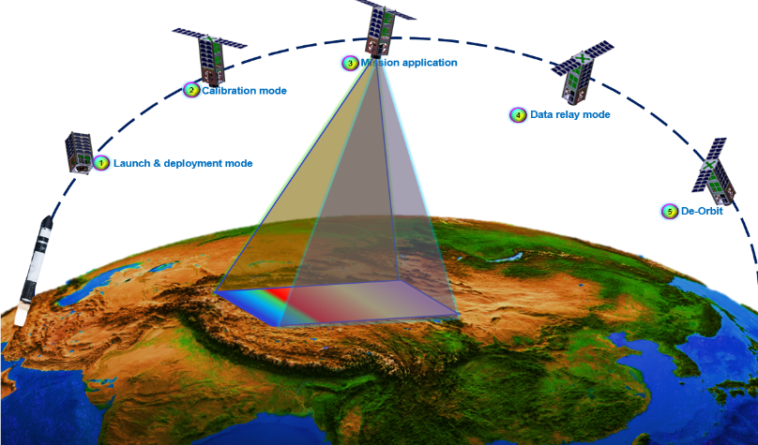

Figure 1: Schematic of ConOps of 3U CubeSat equipped hyperspectral optical imaging payload

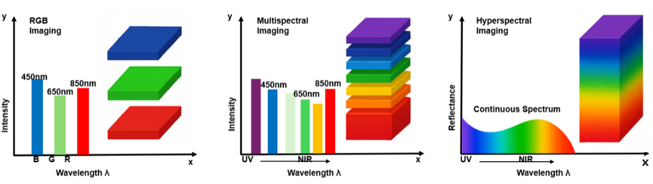
Since the inception and early development of smallsat including CubeSat, many missions, programs, technological demonstrations, and experimental investigations on scalability and performance improvement have been done vigorously in various parts of the world. The majority of non-constellation CubeSat research and development appears to have been carried out by the United States (43.1%), followed by Europe (22.3%), Asia (16.5%), and Russia (7.1%) [6].
Figure 2: Simplified overview and comparison of optical imagers including RGB, multispectral, and hyperspectral capabilities.

Moreover, several studies have contributed to the understanding and advancement of optical payload aboard small satellites (e.g., CubeSats, nanosatellites, and micro satellites) with hyperspectral, multispectral, and panchromatic capabilities. Figure 2 demonstrates comparison of optical imagers between RGB (left side), multispectral (center), and hyperspectral (right-side) in terms of spectral range and wavelength. Hyperspectral imagers acquire imagery from hundreds of narrow, contiguous spectral bands, providing detailed spectral information, enabling material identification and quantitative retrievals in Earth observation, planetary science, and environmental monitoring.
Mouroulis et al. [7] conducted trade studies on first-order requirements and technological advancements in multi-and hyperspectral imaging systems to address current scientific needs and enable new applications. Further, Qian [8] presented an overview of spaceborne hyperspectral imager technologies along with mission objectives, emphasizing instrument performance metrics and technical specifications. Till date, several hyperspectral imagers that are compatible with the CubeSat platform have been developed and used in several missions and table 1 depicts some of those payloads. The adoption of hyperspectral imaging using CubeSats cuts across both academic and commercial applications. But due to the volume constraints of CubeSats, several design configurations have been explored with the aim of potentially rendering a more compact, high performance optical payload
Liu et al. [9] designed a freeform pusbroom hyperspectral imager combining a freeform reflective triplet imager and a freeform reflective triplet spectrometer. The design operated at a #F/2 with a 15 degrees cross-track FOV and a 30mm entrance pupil diameter covering a wide spectral range of 400-1700nm (visible to short-wave infrared) while maintaining a high spectral sampling rate. Their nominal design achieves a 5.5𝜇𝑚 average RMS spot size and distortion less than 25% of a pixel, with misalignment tolerances of 10𝜇𝑚, tilt tolerances of 0.35 arcmin, and figure error tolerances of 10 mm on the first 25 Fringe Zernike polynomials. But most importantly, the adoption of freeform surfaces for the optical designed yielded a compact hyperspectral imager with a 91 x 161 x 116mm3 dimension which can be fully contained in a 3U format.
Lee et al. [10] presented a compact imaging spectrometer for use in the STSAT3 microsatellite. The imager was catadioptric telescope with an Offner-type configuration and a customized prism. To further achieve compactness, a curved grating element was used which made it possible to reduce the number of optical elements thereby shortening the optical path. The imager was designed to capture images of the Earth’s surface and atmosphere with a Ground Sampling Distance of 30m across the spectral range of 400 – 1050nm while being compact.
Graham et al. [11] also developed an experimental prototype of a compact, robust, all-aluminum hyperspectral imager based on a freeform three-concentric-mirror (Offner) optical configuration and a freeform diffraction grating operating at F/2.8 with a spectral resolution of 8 nm and employing an InGaAs sensor covering the 0.7–1.7 𝜇m spectral range. This configuration enables broad spectral coverage, accurate moisture assessment, and achieves up to a 30% reduction in RMS wavefront error across both spatial and spectral domains.

Jin et al. [12] presented the optical design of a Ritchey Chrétien-type reflecting telescope for CubeSat missions, utilizing off-axis segmentation techniques with primary rectangular mirror dimensions of 8×8 cm and secondary mirror size of 2.4 × 4.1 cm. The optical payload can capture a 4 ×2.3km region of earth’s surface from a 700 km altitude using a 120×800 CMOS color imaging sensor with an MTF of approximately 0.3 and 3.2 × 2.8mm image area. Their findings reveal a feasible approach for enhancing spatial resolution in CubeSat-based optical telescopes for space exploration. Mouroulis et al. [13] demonstrated a hyperspectral optical imaging payload designed for a 6U CubeSat, with the optomechanical bench compactly integrated within a 4U (20 × 20 cm) frame. The system operates at F/1.8 with a 100 mm focal length, a 10◦ FOV, and 600 cross track pixels, covering a spectral range of 350–1700 nm with 5.7 nm sampling. The spectrometer performed similarly to conventional airborne sensors while significantly reducing size and extending spectral coverage up to 1700 nm.
Esposito and Marchi [14] reported the first on-board demonstration of a small hyperspectral imager with a three-mirror anastigmat (TMA) telescope configuration which enables it with fit into a 1.5U CubeSat form factor. The optical payload had an on-board processing unit to analyze the quality of image data acquired by the HIS payload. This HIS can acquire high-quality imagery data with a radiometric accuracy of less than 5% and sub-pixel geometric performance of 0.48 pixels across track and 0.51 pixels along track.
It is also important to note that advances in space mission design, such as hyperspectral imaging constellations [15] and spacecraft miniaturization, have significantly improved hyperspectral optical payloads in the visible and near-infrared (VNIR) range by incorporating AI-powered analytics to provide actionable Earth observation insights. For example, Esposito et al. [16] presented the first CubeSat mission with on-board AI employing combined hyperspectral and thermal imaging, whilst Aoyanagi [17] developed a 35-g compact hyperspectral camera with a linear variable filter and image sensor.
Studies have demonstrated the viability of integrating hyperspectral imagers into CubeSats. Table 1 shows a list of hyperspectral imagers in the CubeSat format designed for either flight demonstrations or laboratory prototypes. Off-axis optical configuration is used in at least either the fore optics or the spectrometer design. This is due to their ability to achieve high spectral accuracy and at the same time robust mechanical compactness. However, hyperspectral imagers with such design structure suffer difficulties in assembly, alignment, and are generally more costly to fabricate due to the complexity in processing of the concave and convex reflection gratings, which hinders the wider deployment of these instruments commercially [18]. To overcome these limitations, transmissive imaging spectrometers particularly those employing prism–grating (PG) or prism-grating-prism combinations such as the ones employed in [18], [19] [20] have been widely studied in recent years. The prism-grating configuration leverages the complementary dispersion properties of prisms and gratings, enabling correction of spectral smile and enhanced chromatic uniformity across the field of view.
In this article, the design and performance optimization evaluation of a compact transmission-grating–based 3U CubeSat first-order electro-optical hyperspectral imaging payload system based on the flat-field Schimdt-Cassegrain of Catadioptric Telescope (SCT) intended to acquire high quality images from an altitude of 500 km were investigated. The selection of an appropriate imaging sensor, optomechanical design within the CubeSat form factor, and parameters that describe the capabilities and limitations of the CubeSat’s optical instruments are also examined to assess the hyperspectral imager’s performance such as spatial resolution, modulation transfer function, noise characteristics, radiometric accuracy, and distortion levels. The entrance slit of the spectrometer is positioned within the internal cavity of the telescope, precisely at its focal plane. This structural integration allows the fore-optics and spectrometer systems to share a common optical axis, eliminating the need for an external relay assembly and thereby improving co-axial alignment, rigidity, and optical efficiency. The internal-slit configuration also reduces stray-light paths and optical vignetting, while maintaining a compact overall form factor that is well suited for payload miniaturization.
This study is structured as follows: Section 2 discusses the methodology for the HSI optical payload system design approach and requirement definitions, as well as sensor selection and optomechanical system analysis, which covers both optical and structural design analysis. Section 3 covers CubeSat hyperspectral optical imaging payload performance optimization in terms of image quality and aberration, spectra/spatial resolution, SNR/sensitivity analysis, and optical tolerancing. Section 4 summarizes the work.
 | Imager | Configuration | Resolution | Platform (CubeSat) | Spectral range | FOV
1 | SWIS | TMA + Dyson | 100 x 200 x 200 | 6U | 350-1700nm | 10°
2 | Mouroulis [21] | TMA + Dyson | 200 x 200 | 6U | 350–1700 nm | 10°
3 | Liu (2021): [22] | Freeform (off axis) | 100 x 200 x 200 | 3U | 400- 1700 | 15°
4 | HYPSO-1 [23] | Transmission grating |  | 6U | 430–800 nm | 7.8
5 | NACHOS [24] | Refractive elements + Offner |  | 1.5 U of 3 U | 290–500 nm | 15°
6 | Ivliev et al. (2024): [25] | Refractive objective lens + Offner |  | 1.3 U of 3 U | 400–1000 nm | 11°
7 | FINCH EYE [26] | Refractive objective lens + Refractive relay-lens spectrometer |  | 3U | 900–1700 nm | 1.2°

Methodology
2.1 Hyperspectral Imager Design

[1] D. Selva and D. Krejci, “A survey and assessment of the capabilities of Cubesats for Earth observation,” May 2012. doi: 10.1016/j.actaastro.2011.12.014.
[2] P. Chadalavada and A. Dutta, “Regional CubeSat Constellation Design to Monitor Hurricanes,” IEEE Transactions on Geoscience and Remote Sensing, vol. 60, 2022, doi: 10.1109/TGRS.2021.3124473.
[3] J. N. Pelton and S. Madry, Handbook of Small Satellites: Technology, Design, Manufacture, Applications, Economics and Regulation: With 476 Figures and 92 Tables. Springer International Publishing, 2020. doi: 10.1007/978-3-030-36308-6.
[4] D. Gadisa and H. Bang, “Small Satellite Electro-Optical System (EOS) Technological and Commercial Expansion,” Dec. 01, 2023, Elsevier Ltd. doi: 10.1016/j.actaastro.2023.09.010.
[5] R. Sandau, “Status and trends of small satellite missions for Earth observation,” Jan. 2010. doi: 10.1016/j.actaastro.2009.06.008.
[6] M. Swartwout, “Cubesat census.” Accessed: Dec. 03, 2025. [Online]. Available: https://sites.google. com/a/slu.edu/swartwout/cubesat-database/census?authuser=0.
[7] P. Mouroulis et al., “Trade Studies in Multi/hyperspectral Imaging Systems Final Report.”
[8] S. E. Qian, “Hyperspectral Satellites, Evolution, and Development History,” 2021, Institute of Electrical and Electronics Engineers Inc. doi: 10.1109/JSTARS.2021.3090256.
[9] Y. Liu, A. Bauer, T. Viard, and J. P. Rolland, “Freeform hyperspectral imager design in a CubeSat format,” Opt Express, vol. 29, no. 22, p. 35915, Oct. 2021, doi: 10.1364/oe.439530.
[10] J. H. Lee, T. S. Jang, H. S. Yang, and S. W. Rhee, “Optical design of a compact imaging spectrometer for STSAT3,” J Opt Soc Korea, vol. 12, no. 4, pp. 262–268, 2008, doi: 10.3807/JOSK.2008.12.4.262.
[11] C. Graham, J. M. Girkin, and C. Bourgenot, “Freeform based hYperspectral imager for MOisture Sensing (FYMOS),” 2021.
[12] H. Jin, J. Lim, Y. Kim, and S. Kim, “Optical Design of a Reflecting Telescope for CubeSat,” J Opt Soc Korea, vol. 17, no. 6, pp. 533–537, Dec. 2013, doi: 10.3807/josk.2013.17.6.533.
[13] P. Mouroulis, B. Van Gorp, R. O. Green, and D. W. Wilson, “Optical design of a CubeSat-compatible imaging spectrometer,” in Imaging Spectrometry XIX, SPIE, Sep. 2014, p. 92220D. doi: 10.1117/12.2062680.
[14] M. Esposito and A. Zuccaro Marchi, “In-orbit demonstration of the first hyperspectral imager for nanosatellites,” SPIE-Intl Soc Optical Eng, Jul. 2019, p. 71. doi: 10.1117/12.2535991.
[15] K. K. Awais Ahmed, “Pixxel hyperspectral imaging constellation.” Accessed: Dec. 29, 2025. [Online]. Available: https://www.pixxel.space/hyperspectral-imagery.
[16] M. Esposito, S. S. Conticello, M. Pastena, and B. Carnicero Dominguez, “In-orbit demonstration of artificial intelligence applied to hyperspectral and thermal sensing from space,” SPIE-Intl Soc Optical Eng, Aug. 2019, p. 11. doi: 10.1117/12.2532262.
[17] Y. Aoyanagi, “On-orbit demonstration of a linear variable band-pass filter-based miniaturized hyperspectral camera for CubeSats,” J Appl Remote Sens, vol. 18, no. 04, Oct. 2024, doi: 10.1117/1.jrs.18.044512.
[18] X. Zhang et al., “Design of a Prism-Grating Wide Spectral Range Transmittance Imaging Spectrometer,” Sensors, vol. 23, no. 11, Jun. 2023, doi: 10.3390/s23115050.
[19] Q. Xue et al., “Underwater hyperspectral imaging system using a prism–grating–prism structure,” Appl Opt, vol. 60, no. 4, p. 894, Feb. 2021, doi: 10.1364/ao.415351.
[20] C. Song, K. Yuan, and W. Zhou, “Design of an High-Speed Near-Infrared Hyperspectral Camera Using Prism-Grating Dispersion,” in 2025 23rd International Conference on Optical Communications and Networks, ICOCN 2025, Institute of Electrical and Electronics Engineers Inc., 2025. doi: 10.1109/ICOCN67308.2025.11145739.
[21] H. A. Bender et al., “Snow and Water Imaging Spectrometer (SWIS): optomechanical and system design for a CubeSat-compatible instrument,” in Imaging Spectrometry XX, SPIE, Sep. 2015, p. 961103. doi: 10.1117/12.2190013.
[22] Y. Liu, A. Bauer, T. Viard, and J. P. Rolland, “Freeform hyperspectral imager design in a CubeSat format,” Opt Express, vol. 29, no. 22, p. 35915, Oct. 2021, doi: 10.1364/oe.439530.
[23] S. Bakken et al., “HYPSO-1 CubeSat: First Images and In-Orbit Characterization,” Remote Sens (Basel), vol. 15, no. 3, Feb. 2023, doi: 10.3390/rs15030755.
[24] S. P. Love et al., “NACHOS, a CubeSat-based high-resolution UV-Visible hyperspectral imager for remote sensing of trace gases: system overview and science objectives,” SPIE-Intl Soc Optical Eng, Aug. 2021, p. 14. doi: 10.1117/12.2594336.
[25] N. Ivliev et al., “3U CubeSat-Based Hyperspectral Remote Sensing by Offner Imaging Hyperspectrometer with Radially-Fastened Primary Elements,” Sensors, vol. 24, no. 9, May 2024, doi: 10.3390/s24092885.
[26] I. Shofman, M. G. Neto, T. Ganesh, K. He, A. Armstrong, and K. Narkevich, “SSC25-P1-22 FINCH EYE: The Optical and Optomechanical Design of a GRISM-based SWIR Hyperspectral Imaging Payload for a 3U CubeSat.”

